Texas Hold’Em Poker Benefit
Proceeds to benefit the Ryan & Lauren Fairholm Education Fund

After an incredibly hard fought battle with cancer, our beloved friend Gordon Fairholm passed away on November 23, 2017. Amongst many, he has left behind his devoted wife (Lisa) and two wonderful kids; Ryan and Lauren who are just in the beginnings of their high school years. As a way to help Gord’s children with their academic pursuits, a poker evening will be held with all the proceeds going to their post-secondary education.
In order to make this happen, we are seeking your assistance. Below are the numerous ways you can help.
Tickets to attend $50 Includes: Finger food buffet
1 free drink (beer/wine/soft drink)
Sponsor a table $250 Table Top Sign Displayed
Acknowledgement in Speeches
Make a Prize donation Acknowledgement in Speeches
Acknowledgement on printed material
Make a Cash Donation
Your kind support is appreciated. Unlike other fund raising initiatives, this event guarantees every dollar profited will go towards the kid’s post-secondary education.
Event Taking Place on Thursday Feb 22nd, 2018
At Traffic Tech Office- 16711 Trans Canadienne, Kirkland, PQ H9H3L1
**Park at the back entrance of the building**
From 7:00pm-11:00pm
Door Prizes Available

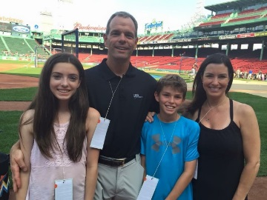

Please fill out the below portion and be sure to include your logo/ads if you are sponsoring a table.
Name
Email address
Phone Number
Type of Donation
Checks made payable to:

